Training on
“Strengthening the Role of Judicial Committees and Ward Chairs”
from 13th -18th May in Gaindakot, Chitwan
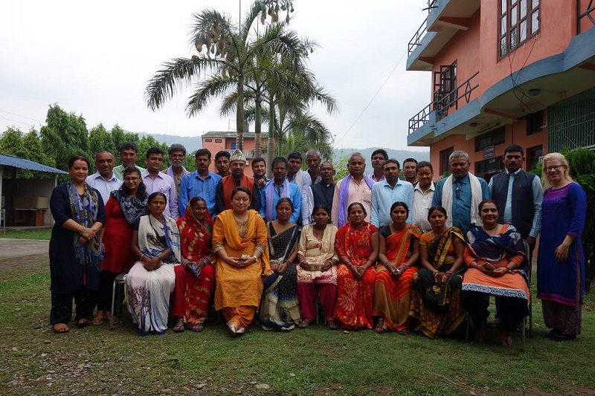
Propublic, with the support of GIZ/ZFD organized a six-day residential training on ‘Strengthening the Role of Judicial Committee and Ward Chairs’ from May 13 to 18, 2018 in Gaidakot, Nawalparasi. The training was designed for Judicial Communities and Ward Chairs of 6 communities (3 each from Dhanusha and Sarlahi).
Figure 1: Group Picture
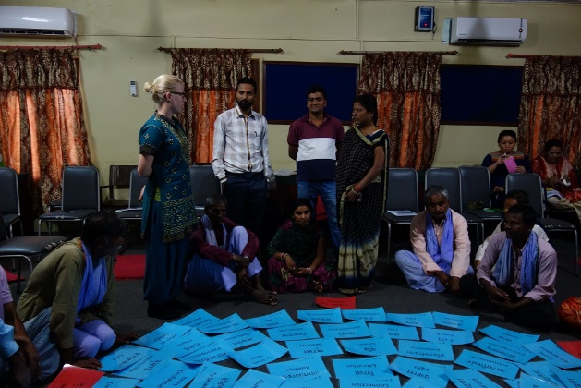
Training focused on theories, group works, lecture method, and refreshers/games. Training module was based on the need assessment and the information shared by the participants that included about the challenges they are facing in their roles and work. The contents included; Judicial Systems(formal and informal), introduction of rules and regulations, scope and functions of the Judicial Committee and Ward Chairs, process of dispute resolution, general communication skills, collaboration and mediation and its significance for peaceful community and Nonviolent Communication(NVC).
Figure 2: Participants reacting on Ocean of needs
The first three days of the training focused on skills of NVC that included connecting and disconnecting communication, 4 Ds of disconnections, observation and evaluation, feelings and needs ,four ways of liste ning, how to make request and collaboration. The NVC Session ended with the participants requesting to have similar trainings for Mayors, as they believed this will help in creating more synergy in the working environment.
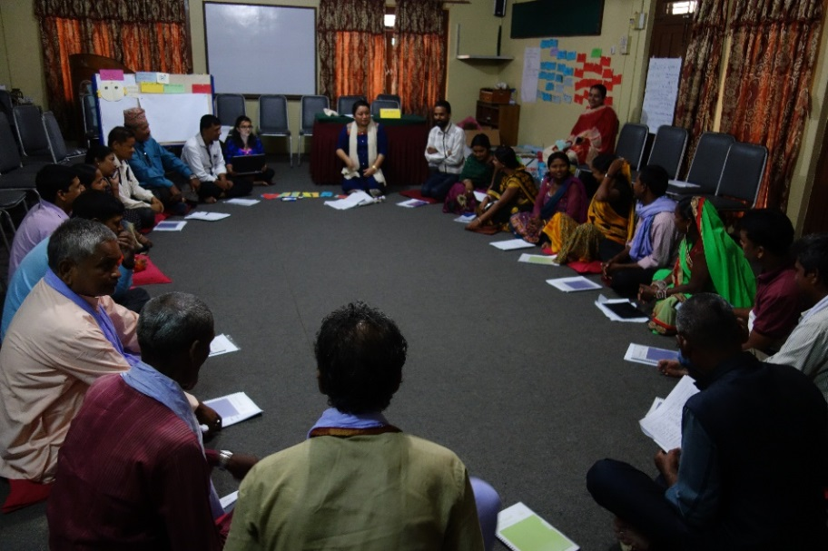
The last two days of the training emphasized on justice system (both formal/ informal) and dispute resolution, clarity on the constitutional and legal provisions, introduction of the rules and regulations for the Judicial Committee/Ward Chairs, and on role clarification and scope of their work. The final day focused on the reflection of what has been achieved in the five days and if the needs of the participants were met or not. The entire training ended with the distribution of certificates to the participants.
Figure 3: Session on NVC

